Fall 2023 I Student News

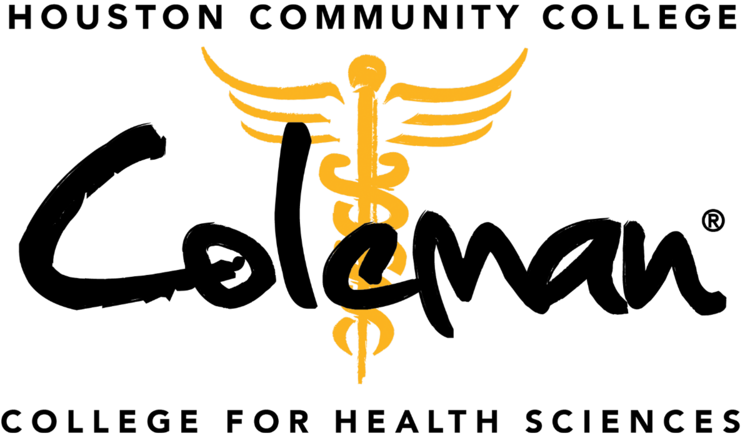

Class of 2023 Pinning Ceremonies
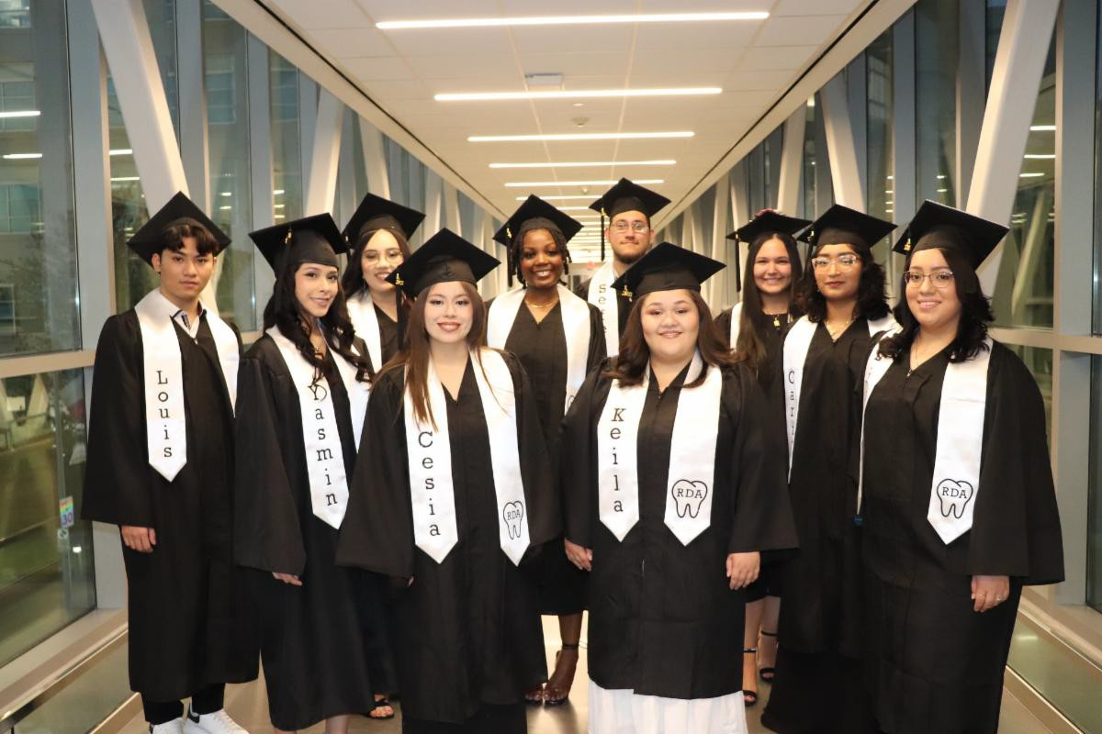
Dental Assisting
Ten Dental Assisting graduates received their pin at the commencement ceremony on Dec. 14 at Coleman Tower atrium.

See the photos!

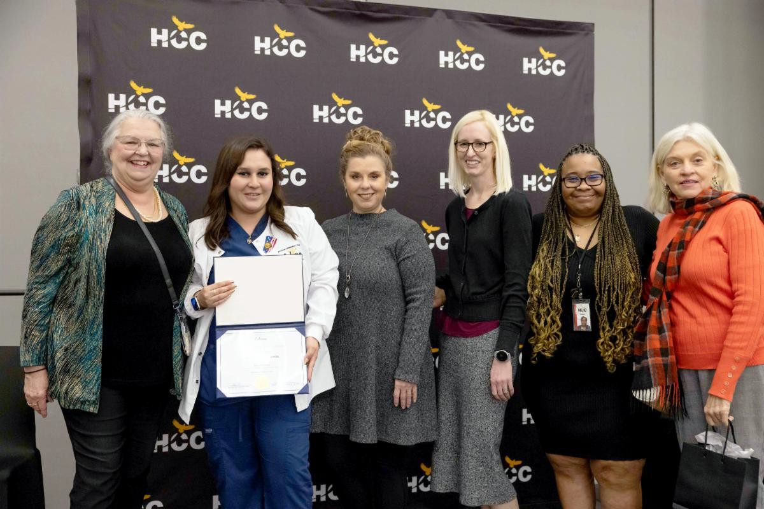
Medical Assistant
Eight Medical Assistant graduates received their pin at the commencement ceremony on Dec. 15 at Coleman Tower atrium.

See the photos!

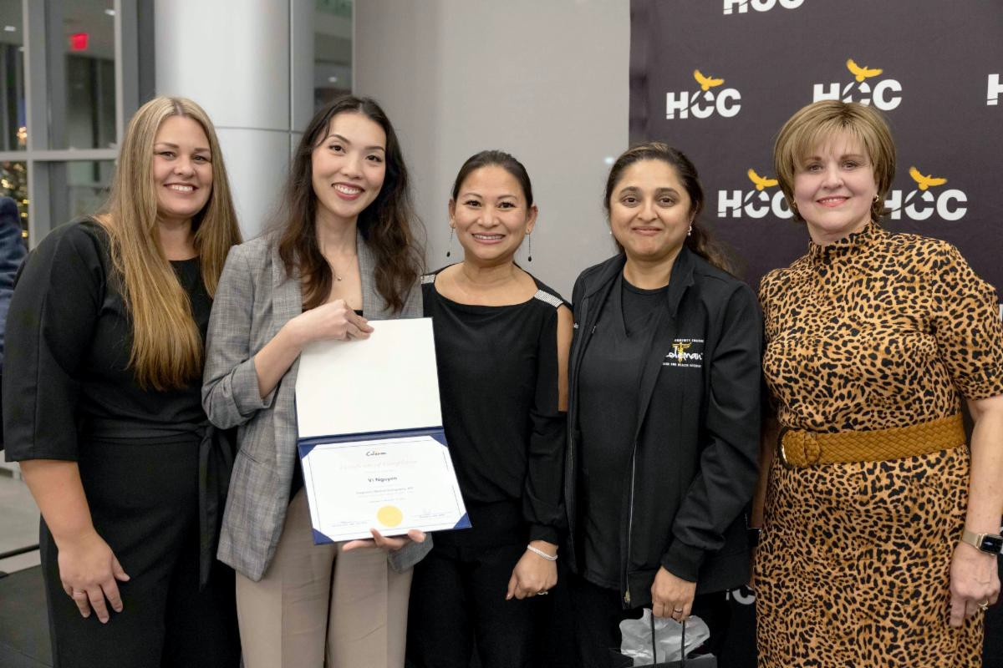
Diagnostic Medical Sonography
Twenty-two Diagnostic Medical Sonography graduates received their pin at the ceremony on
Dec. 15 at Coleman Tower atrium.

See the photos!

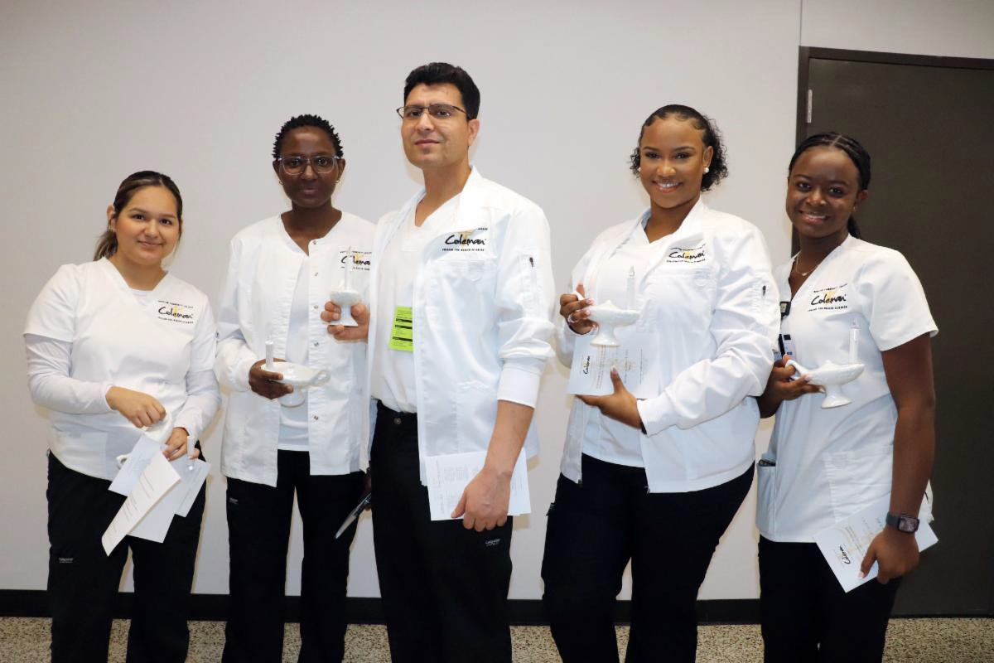
Associate Degree Nursing
Fifty-five Associate Degree Nursing graduates received their pin at the commencement ceremony on Dec. 18 at Central auditorium.

See the photos!

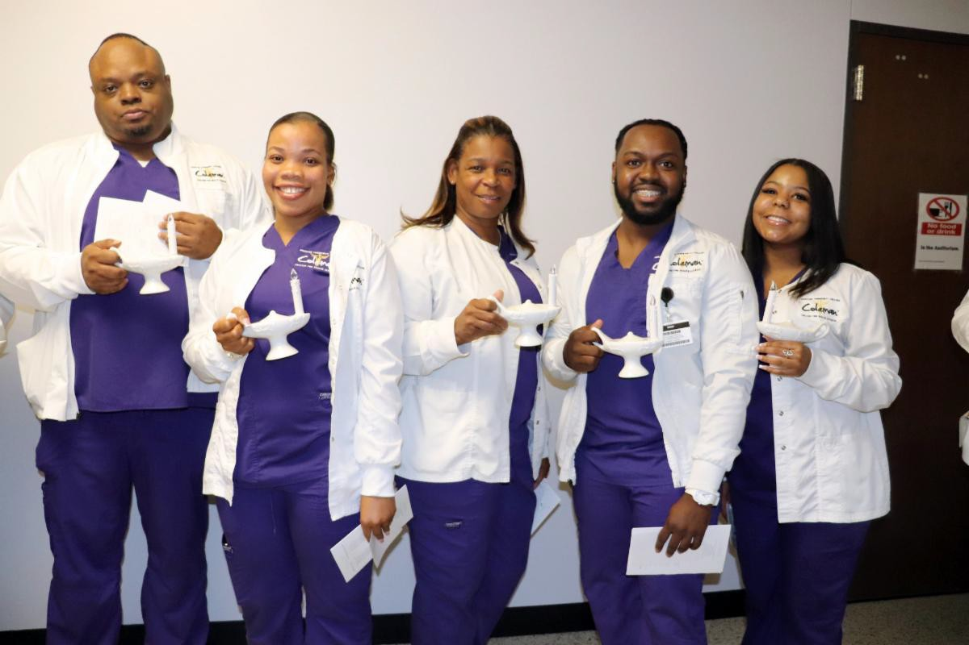
Licensed Vocational Nursing
Thirty-six Licensed Vocational Nursing graduates received their pin at the commencement ceremony on Dec. 18 at Central auditorium.

See the photos!

News Worthy
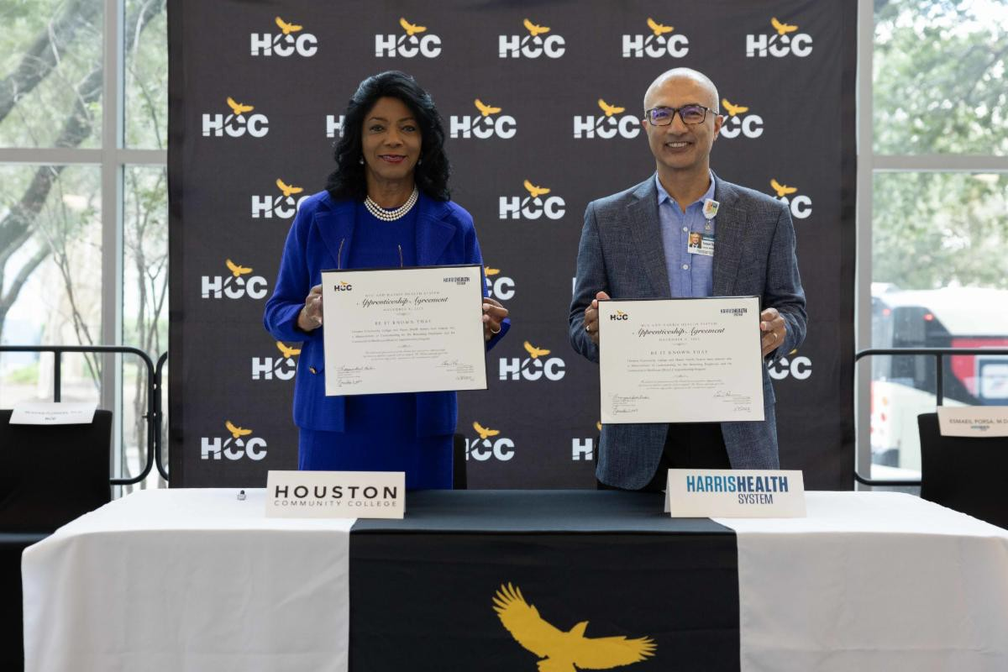
HCC-Harris Health MOU Signing
HCC and Harris Health System signed an apprenticeship agreement on Nov. 8 to develop more patient care technicians.

Read the story!

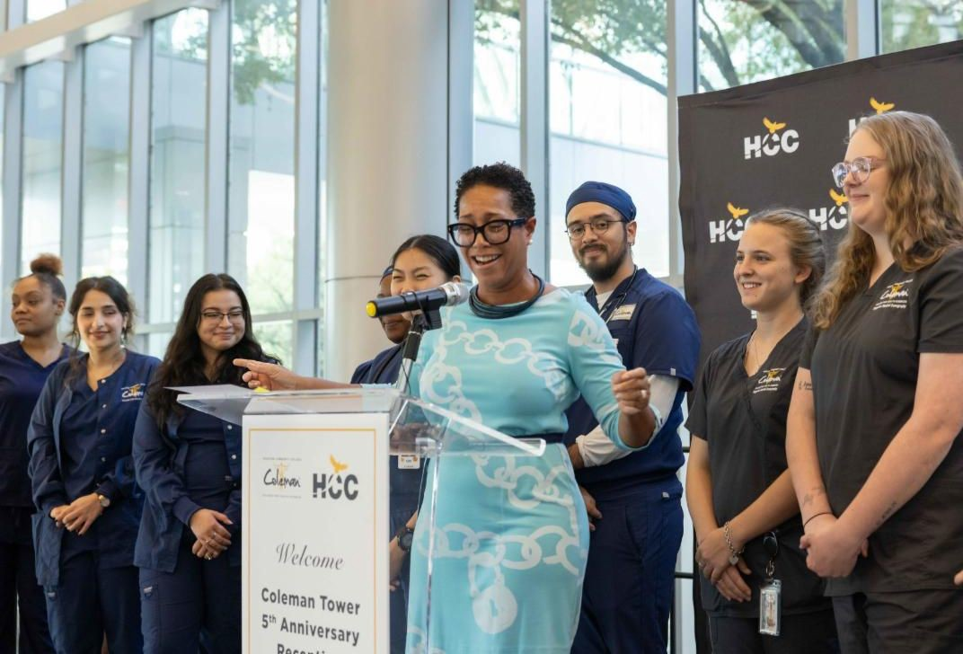
Coleman Tower 5th Anniversary
Healthcare students and community partners shined at the Coleman Tower 5th Anniversary Reception on Sept. 28.

Read the story!

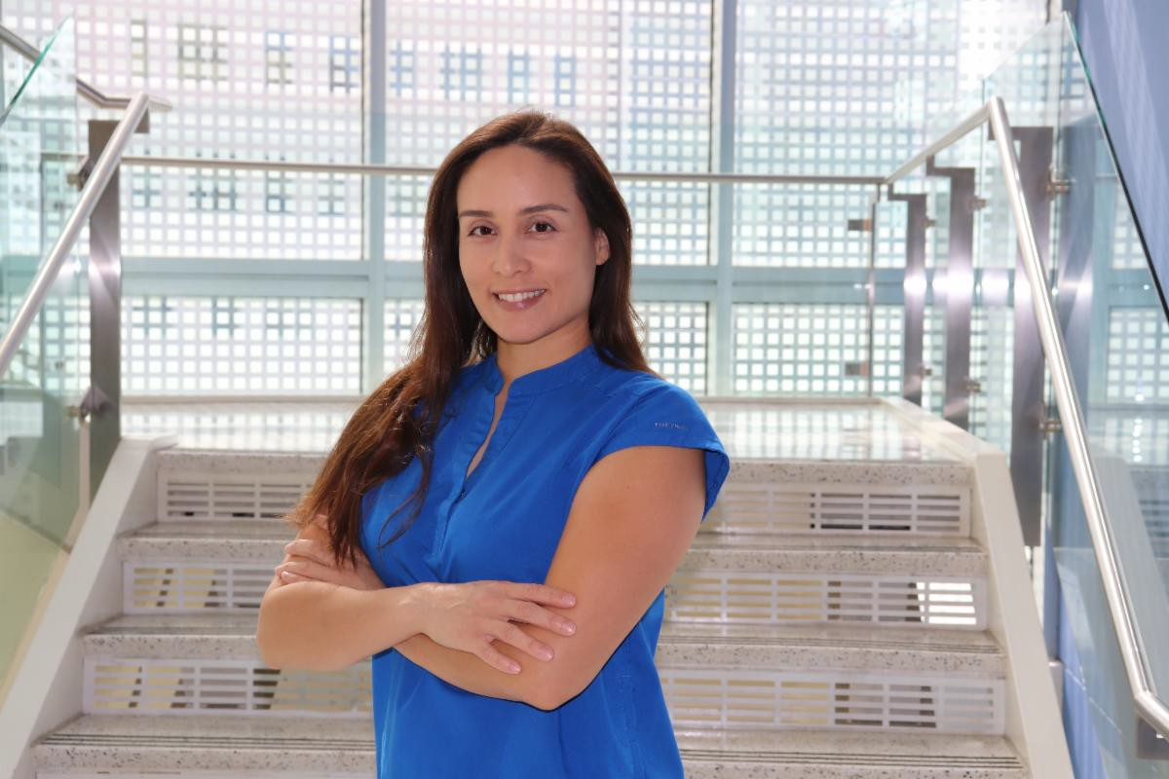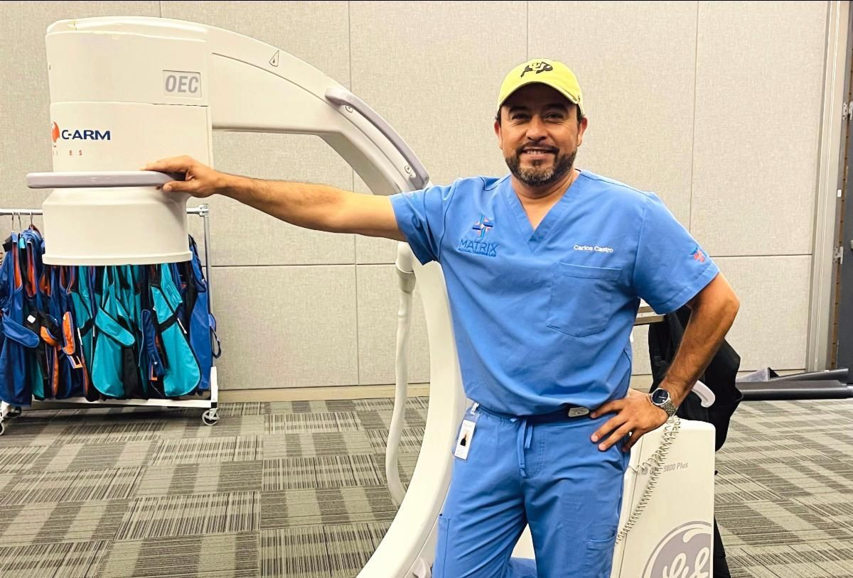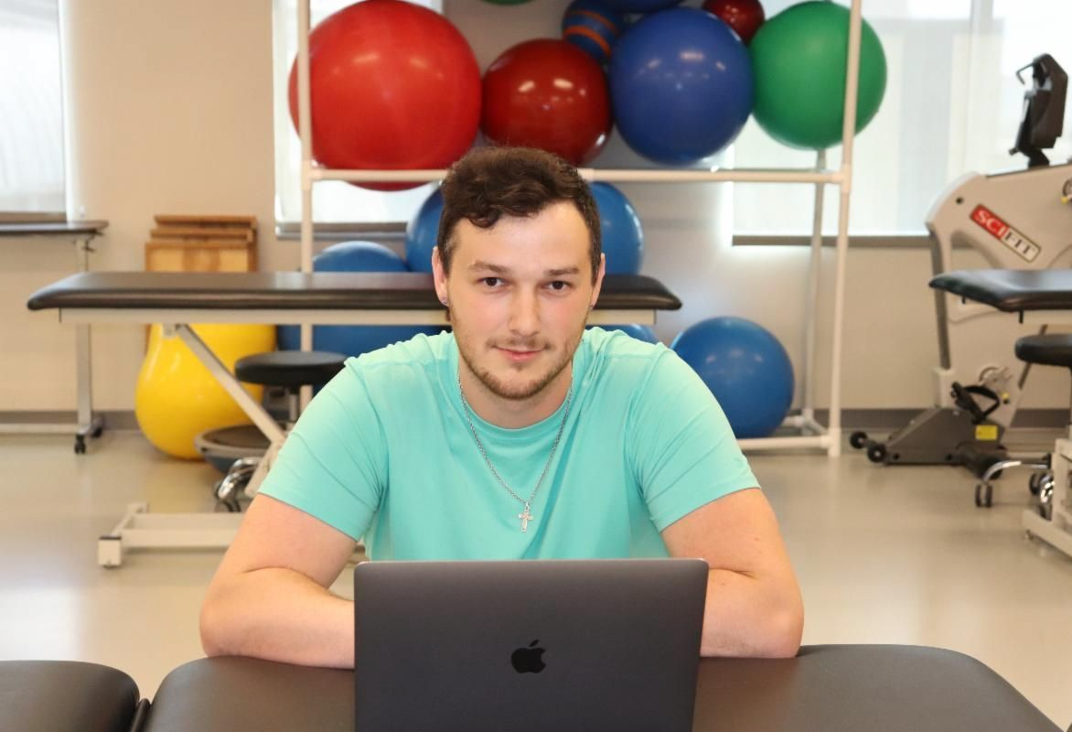

$10K Scholarship Winner

Dental Hygiene student Maren Jensen wins the Dr. Alexanderia K. Lane Memorial Scholarship!
Read her story!
Carlos' Story

Discover how Carlos Castro, Class of 2002, went from an X-ray technologist to an imaging entrepreneur!
Read his story!
Parents Head Back to Class

Three Coleman students with different career dreams share one reason to succeed ... their children!
Read their stories!

Visit Coleman's website to read more stories!

Photo Blast
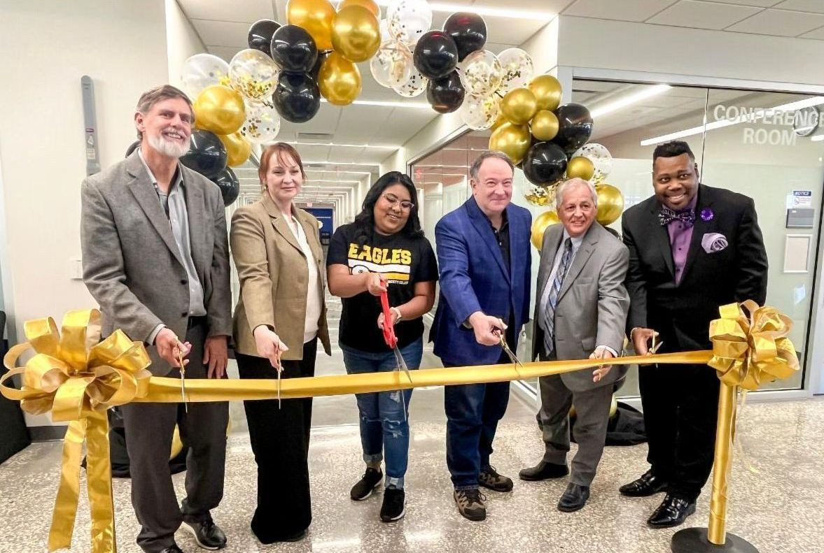
Digital Access Center Opening
The Digital Access Center officially opened at Coleman Tower on Dec.
7. After the ribbon cutting, students
and guests explored the new space!

See the photos!

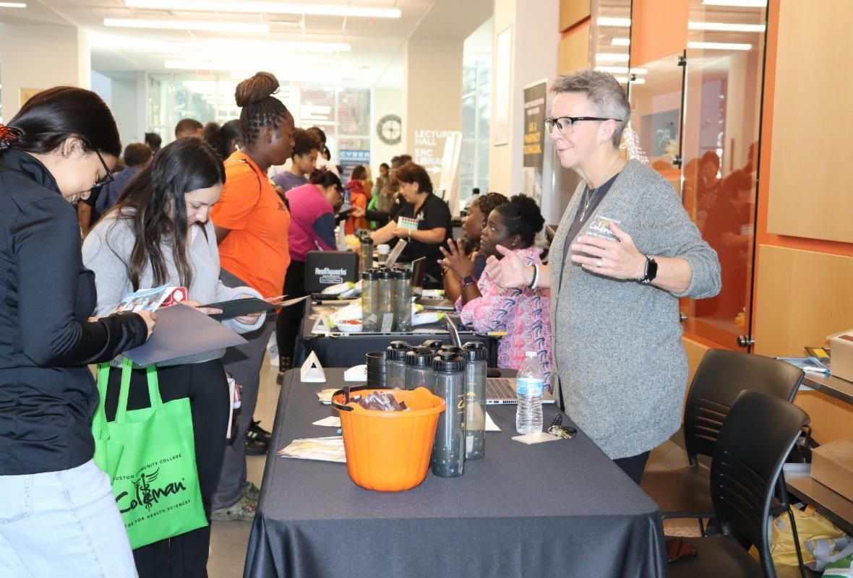
Eagle Preview Day
More than 200 people attended Eagle Preview Day at the Coleman Tower Atrium on Oct. 21. It was a morning of info, tours and fun!

See the photos!

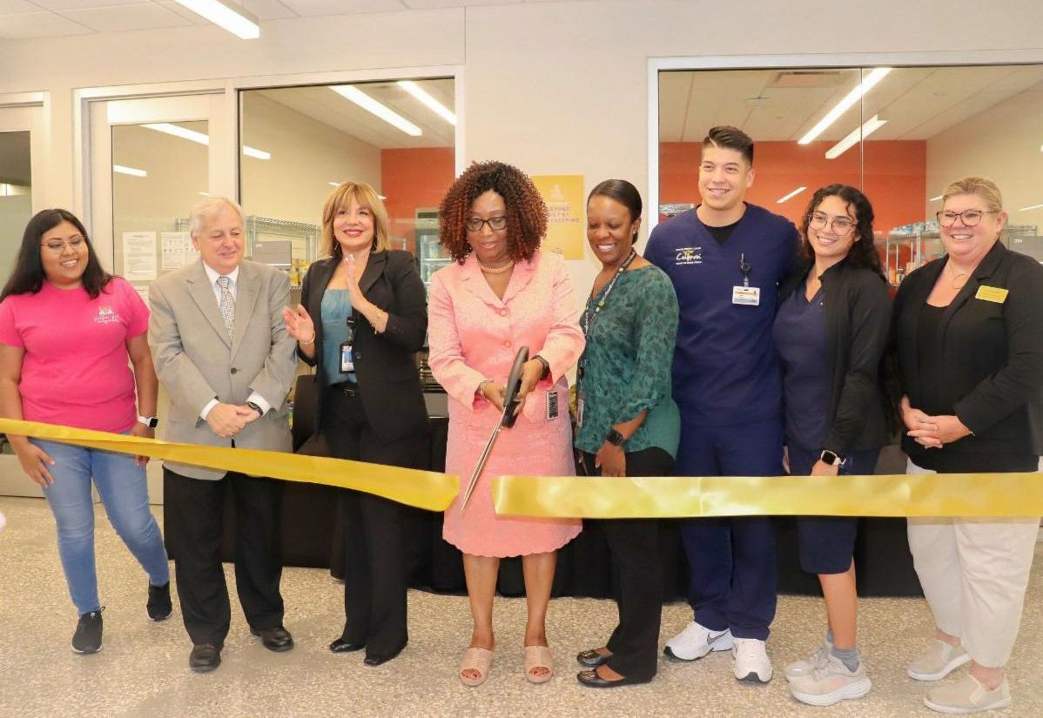
Eagle Market Ribbon Cutting
The Eagle Market at Coleman Tower opened on Oct. 3. Students "shopped" the pantry and enjoyed refreshments and chair massages!

See the photos!

Visit Coleman's Flickr to see more albums!

Soaring Students
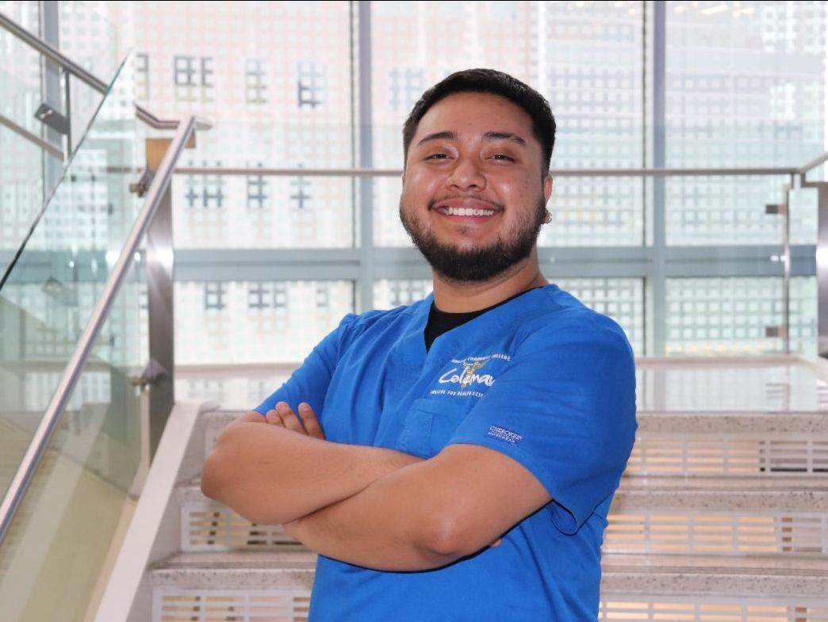
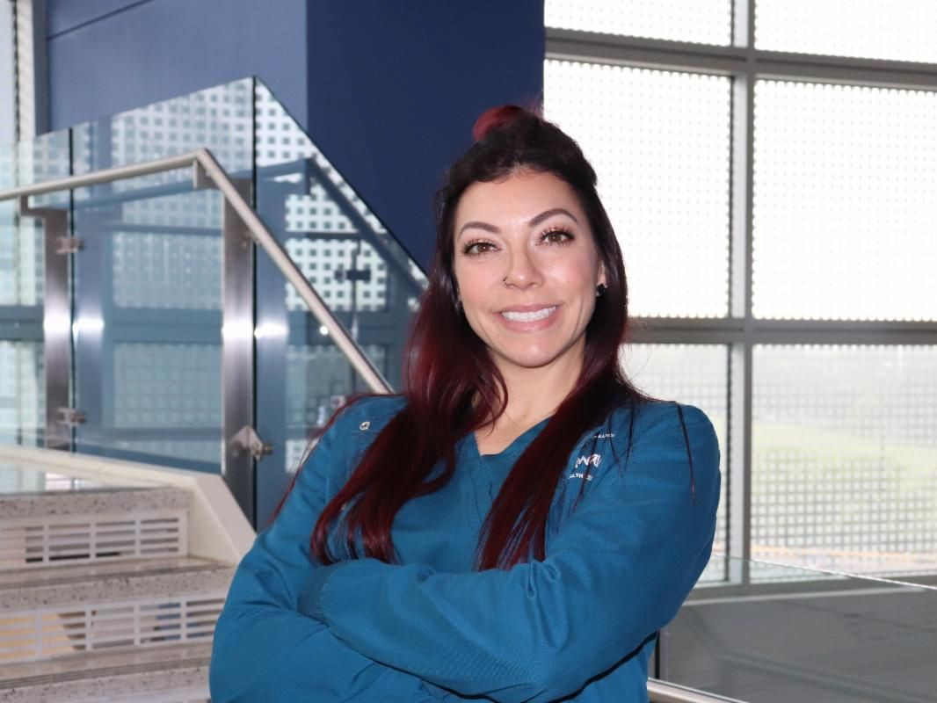
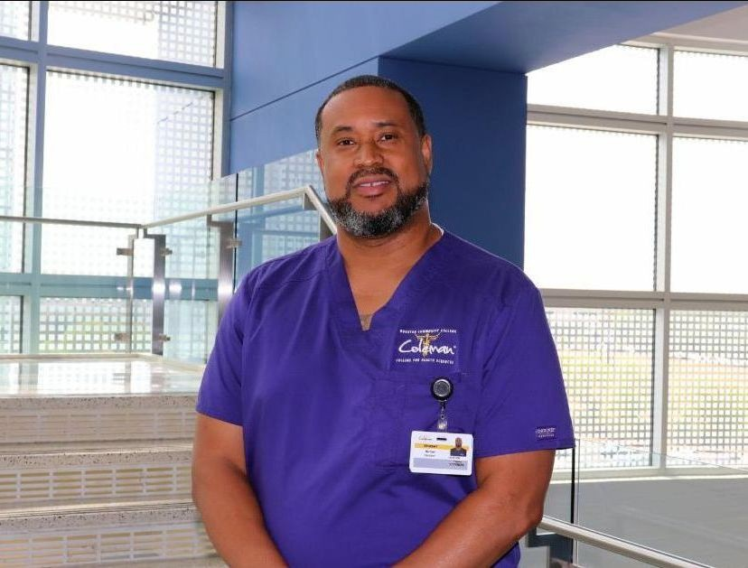

Coleman Champion: Andrik Borjas

Read his profile!
Coleman Champion: Taris Bergerson

Read her profile!
Coleman Champion: Michael Houston

Read his profile!

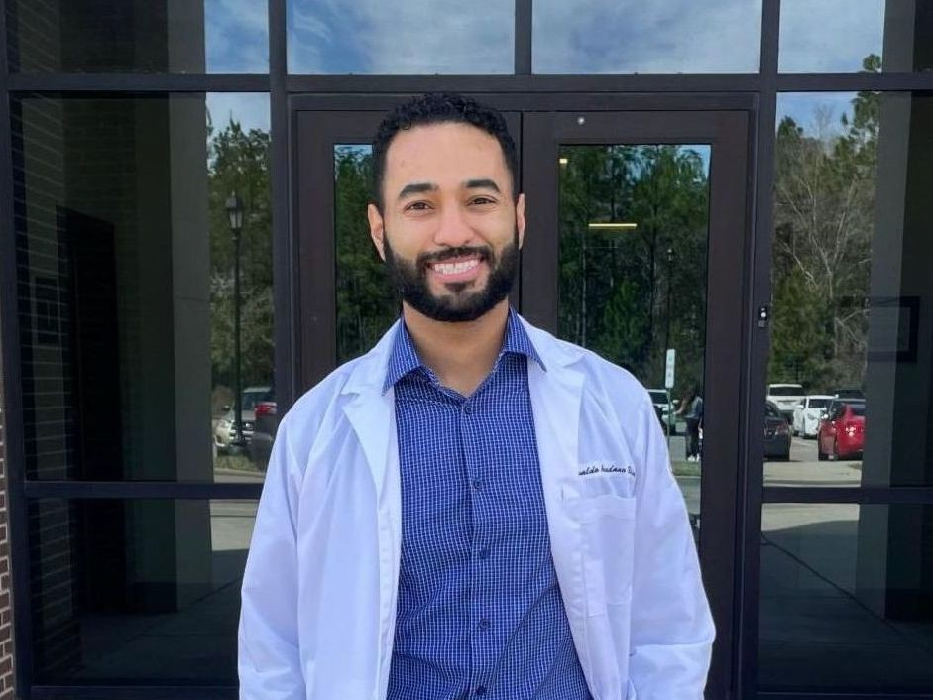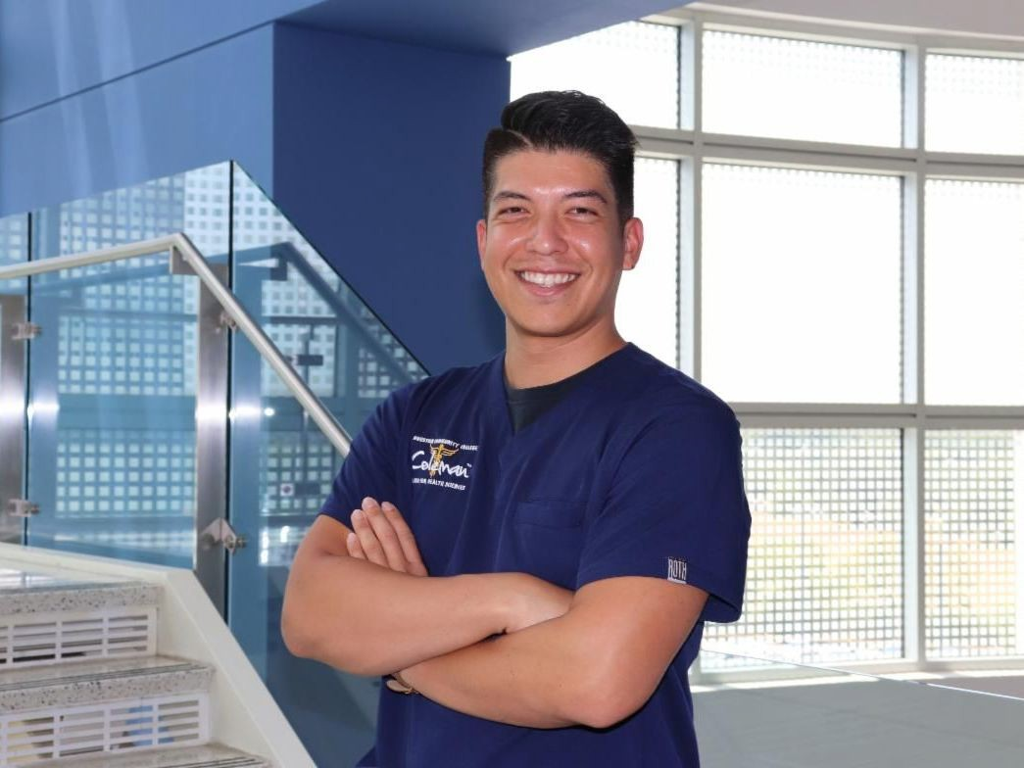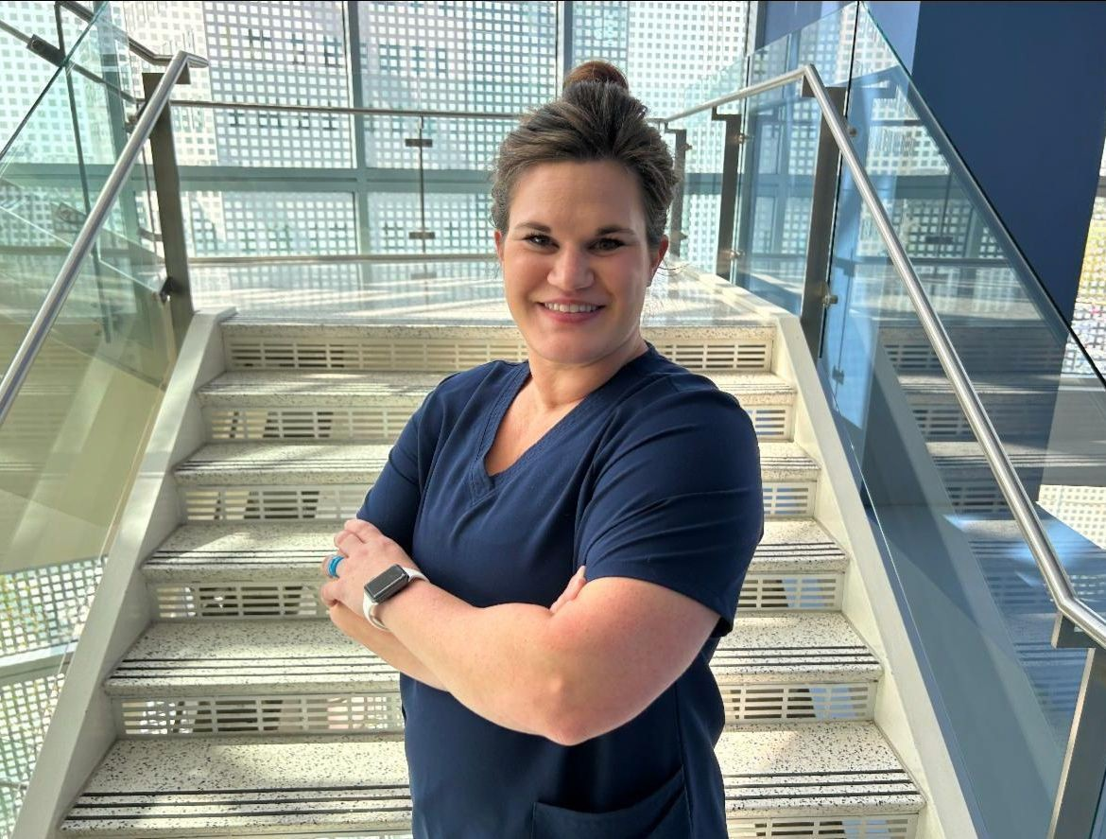

Coleman Colleague: Oswaldo Avendano

Read his profile!
Coleman Champion: Isaias Fajardo

Read his profile!
Coleman Colleague: Charlsey Jimenez

Read her profile!

Visit Coleman's website to see more students and alumni!

Reel Talk

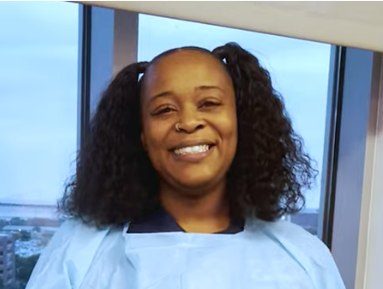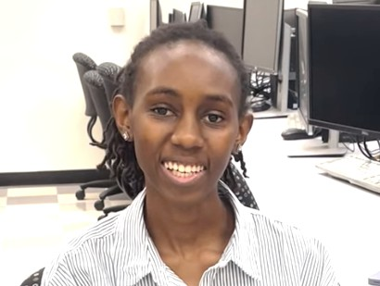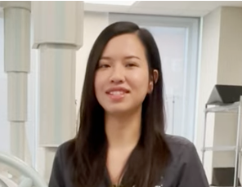

Carnessia Rhodes Endoscopy

Hear her testimonial!
Desmar Ngei Health Information

Hear her testimonial!
Linh Bui Radiography

Hear her testimonial!

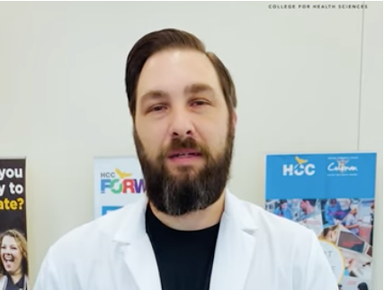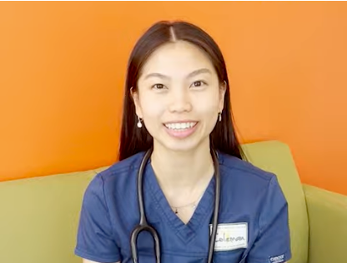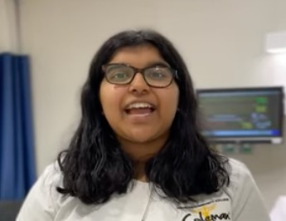

Jacob Rickman Nuclear Medicine

Hear his testimonial!
Gia Tran Respiratory Therapy

Hear her testimonial!
Sneha Jobby Medical Assistant

Hear her testimonial!

Visit Coleman's YouTube to see more videos!

Do you have some Eagle news to share?

Email Coleman Communications!

Follow our social media channels for more stories, photos, profiles, and testimonials!

PDF Version

HCC Coleman College | 1900 Pressler St., Houston, TX 77030

Unsubscribe co.communications@hccs.edu

Update Profile | Constant Contact Data Notice Sent by co.communications@hccs.edu powered by
Try email marketing for free today!

