International Payment TUTORIAL
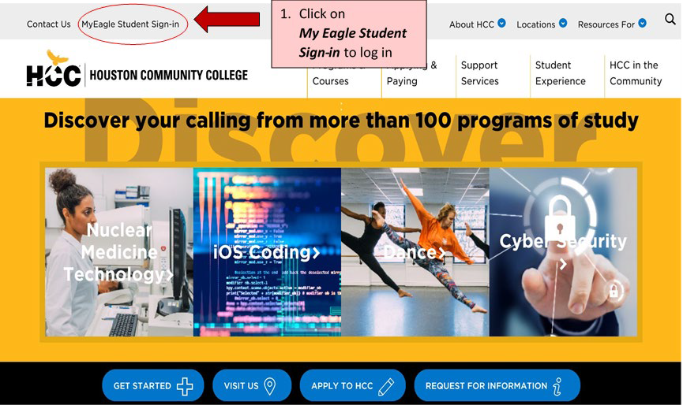

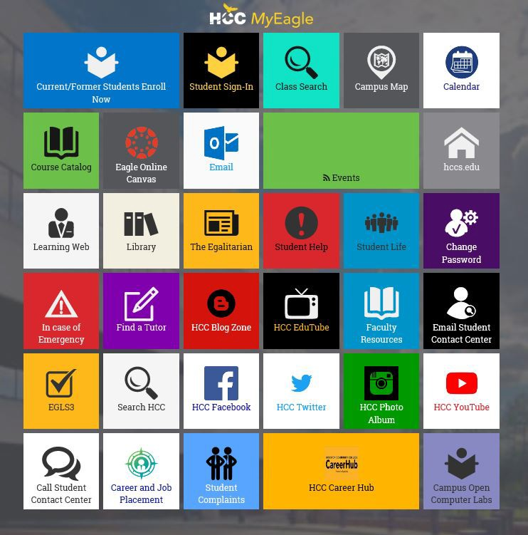

1. Click on Student Sign-in to log in

Enter User ID and Password

Enter your User ID and Password then click ‘Sign In’

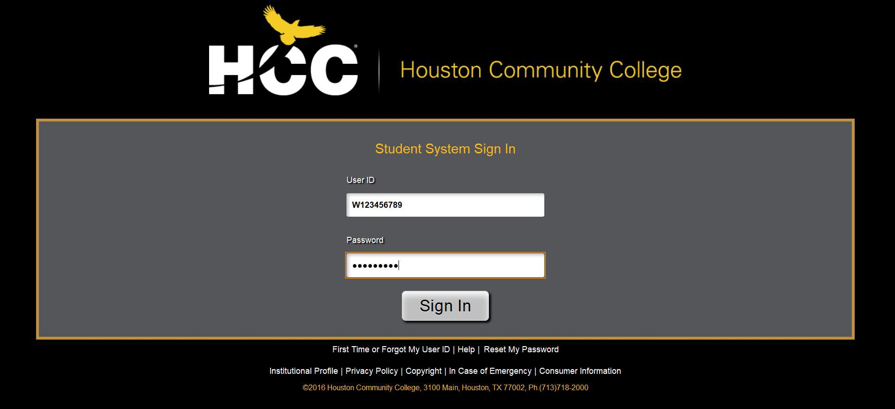If you have not yet set up your online account, click ‘First Time or Forgot My User ID’

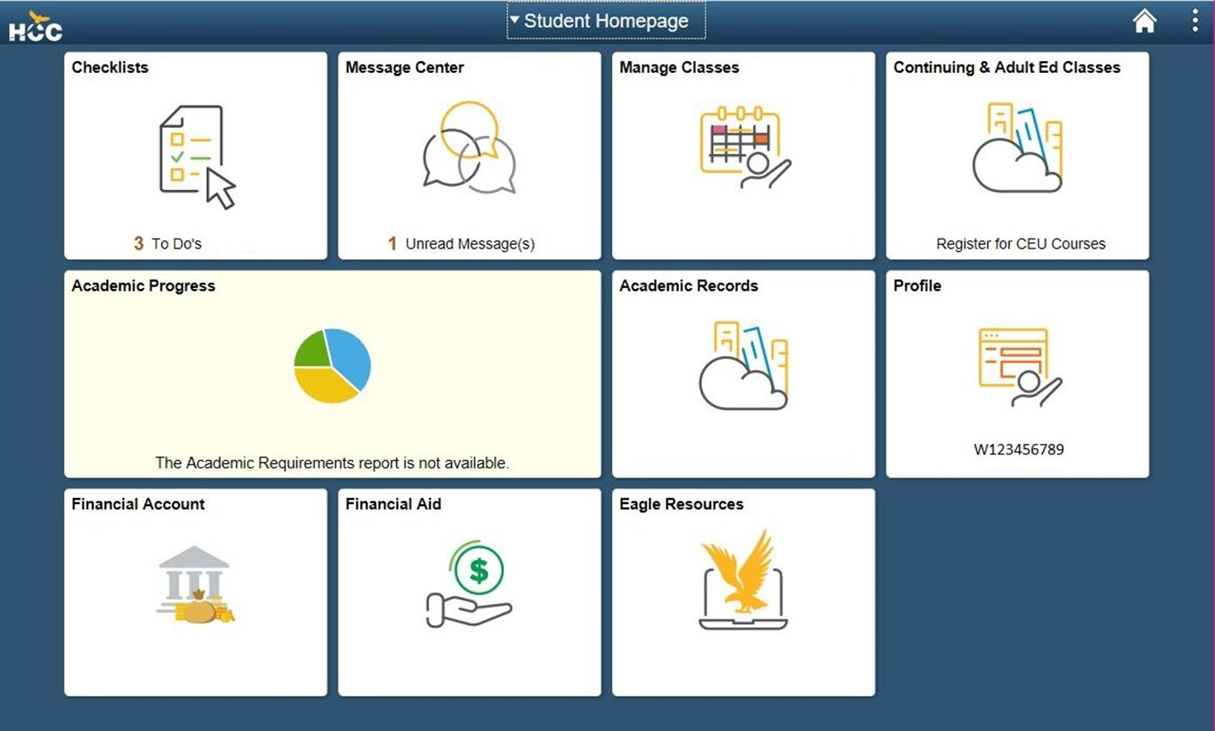

New and returning HCCS
students should ensure to review their Checklists frequently.

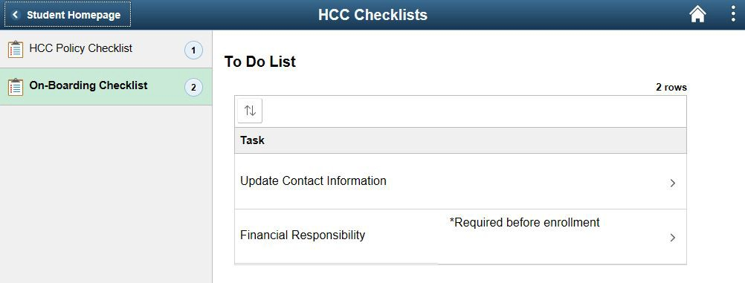

It is important that you keep your Contact Information updated at all times in order to receive communications from HCC. Click on Update Contact Information to review.

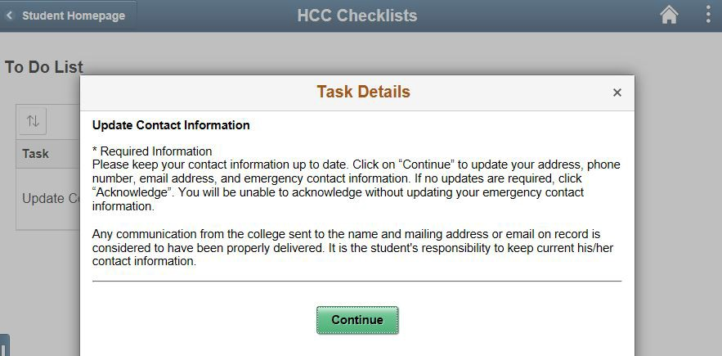

1. Read carefully

2. Click Continue to proceed

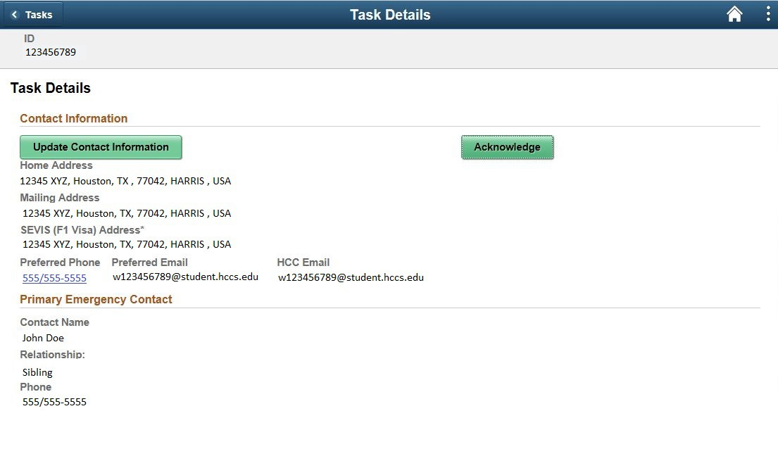

Verify that ALL addresses, phone numbers and emails are up to date.
If any changes need to be made, click on the ‘Update Contact Information’ button.
If no updates are required, click on the ‘Acknowledge’ button.

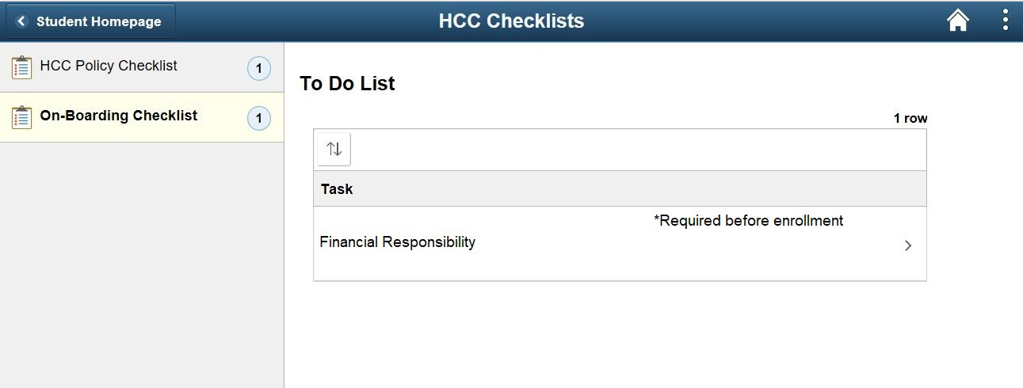Responsibilities

Accept and acknowledge the Student Financial Responsibility and HCC Policies by selecting the
‘Financial Responsibility’ item.
*NOTE: You will be unable to enroll into any courses until this step is completed.

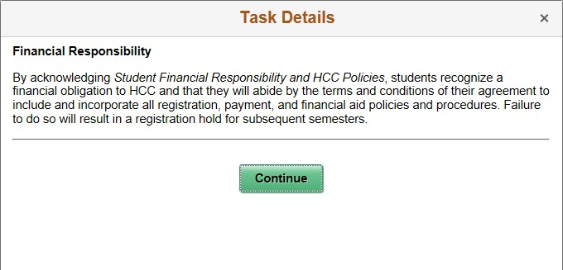
2. Click Continue to proceed
1. Read carefully.

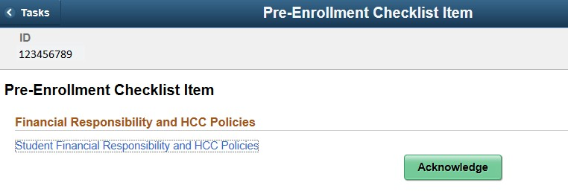
2. Click on the ‘Acknowledge’ button
1. Click on the ‘Student Financial Responsibility and HCC Policies’ link. You will be redirected to the HCCS main website where you will be able to thoroughly review the Student Financial Responsibility Agreement.

Select the ‘Financial Account’ tile to review your account balance(s), check your due date, and submit a payment

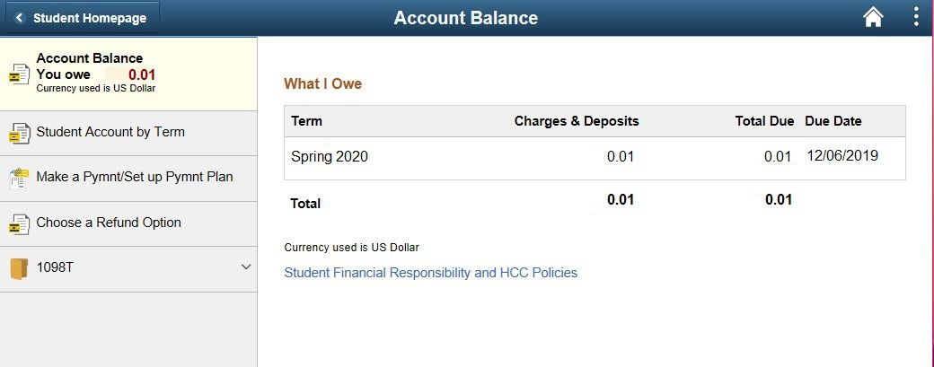
Select ‘Make a Pymnt/Set up a Pymnt Plan’

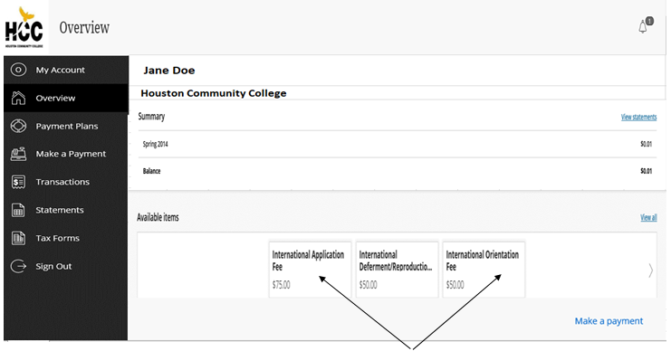
Select the Fee you want to pay

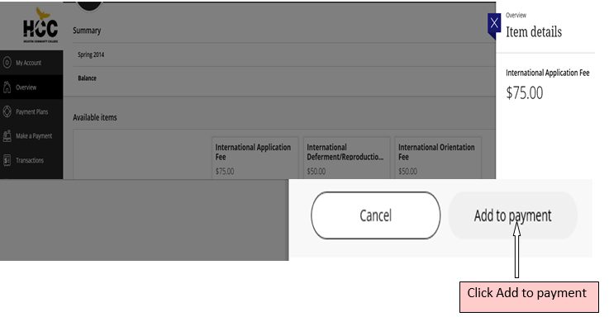

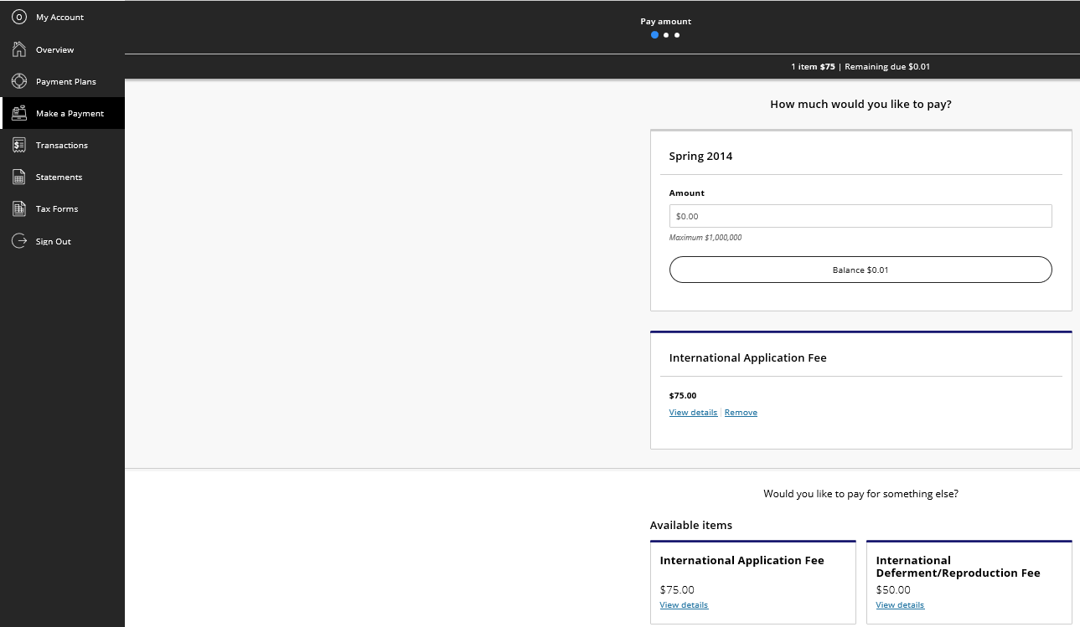

Click Continue

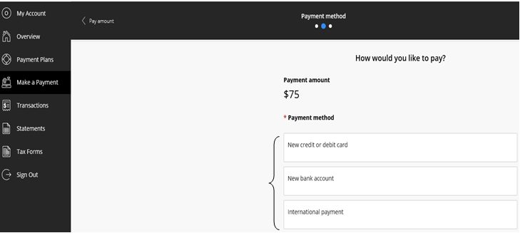
Select Payment Method

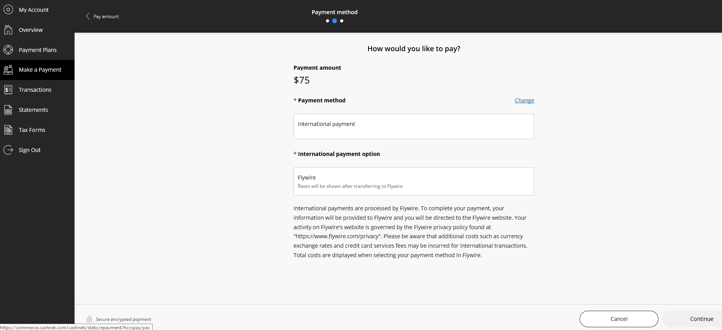
Select International Payment - Flywire and Click ‘Continue’

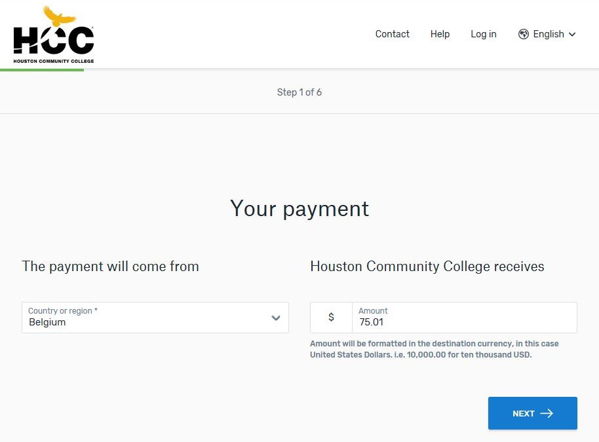

1. Select your country or region from the list of available options

2. Click ‘Next’

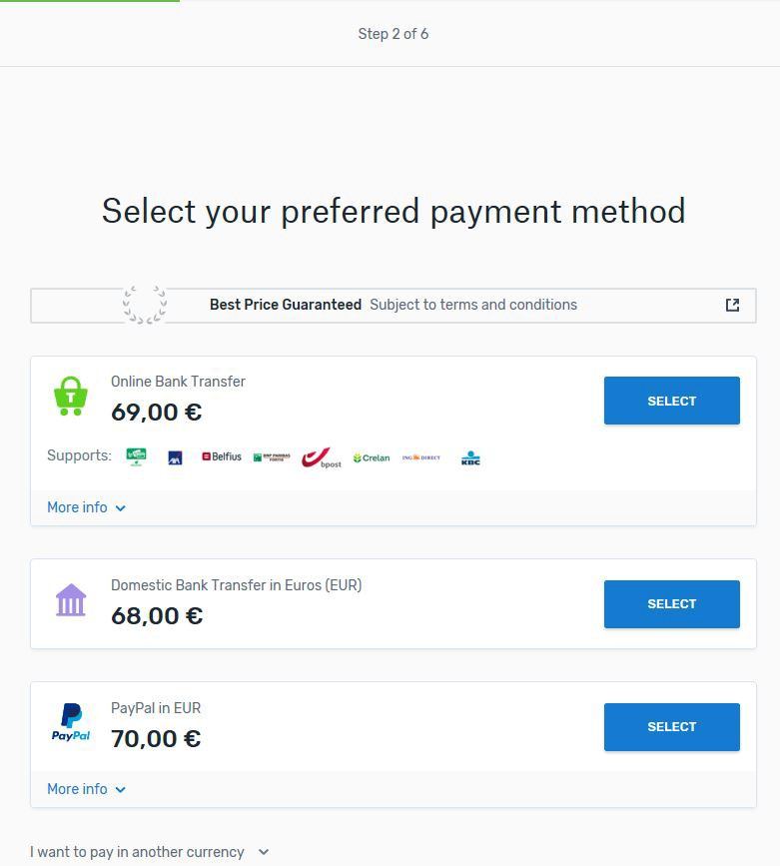Flywire – Select Payment Method

Select one of the payment options displayed on the screen

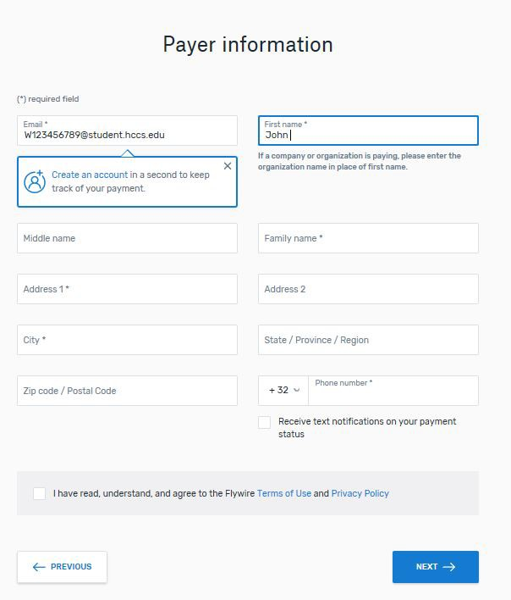
When initially entering payer information, you will be prompted to create a Flywire account to track your current (and future) payments.

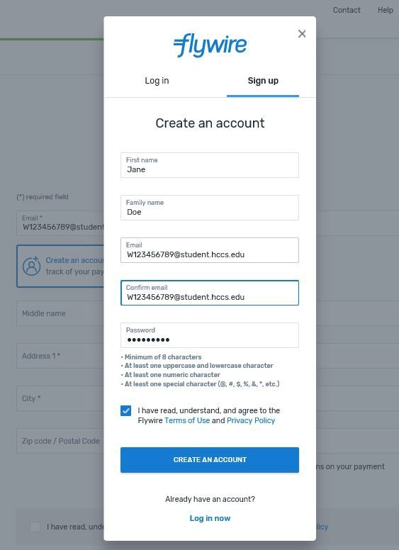

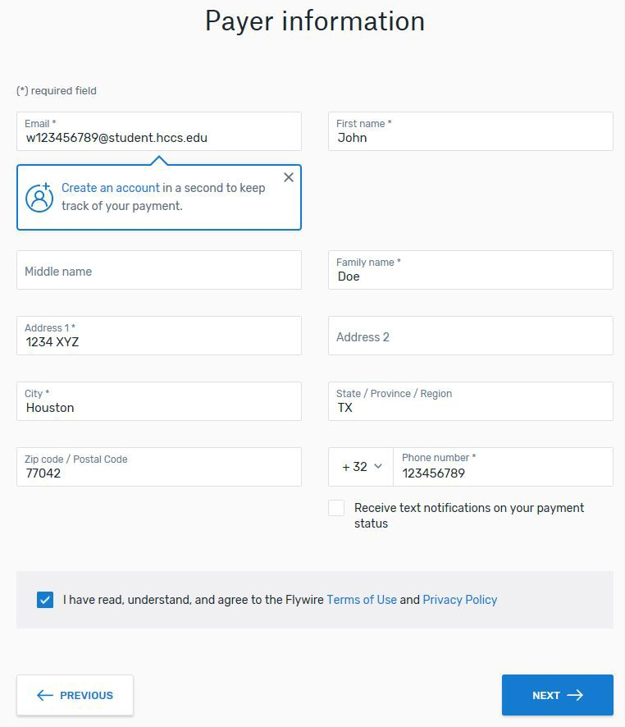
Once you have finished creating your Flywire account, you will then be able to return to the previous screen to finish entering the payer’s information. Be sure to enter the payer’s name and address.

You may enter either a domestic or international phone number to receive text notifications on your payment(s) status. Please ensure that you select the correct country code.

Click on the box to agree to Flywire’s Term of Use and Privacy Policy, and select ‘Next’ to continue.

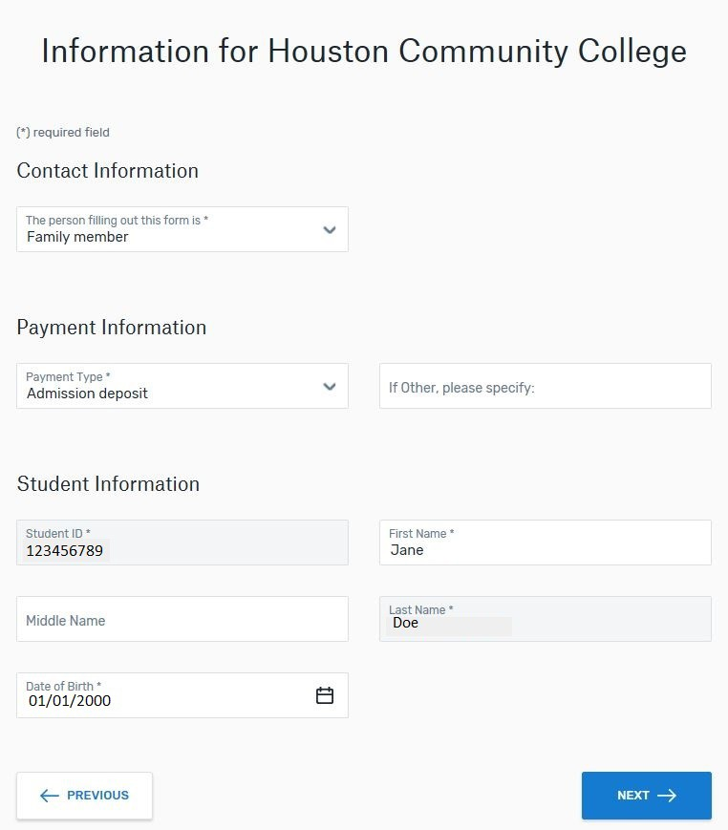
Next, you will provide information of the individual who will request the wire transfer from the international bank.

- Select the Payment Type which best describes the payment. You may select:
  - Student account payment
  - Admission deposit
  - Other
When paying either the International Orientation Fee or the International Application Fee, you must select the ‘Admission Deposit’ option.
1. Indicate the nature of the payer’s relationship to the student.

3. Verify the Student Information is accurate before selecting ‘Next’

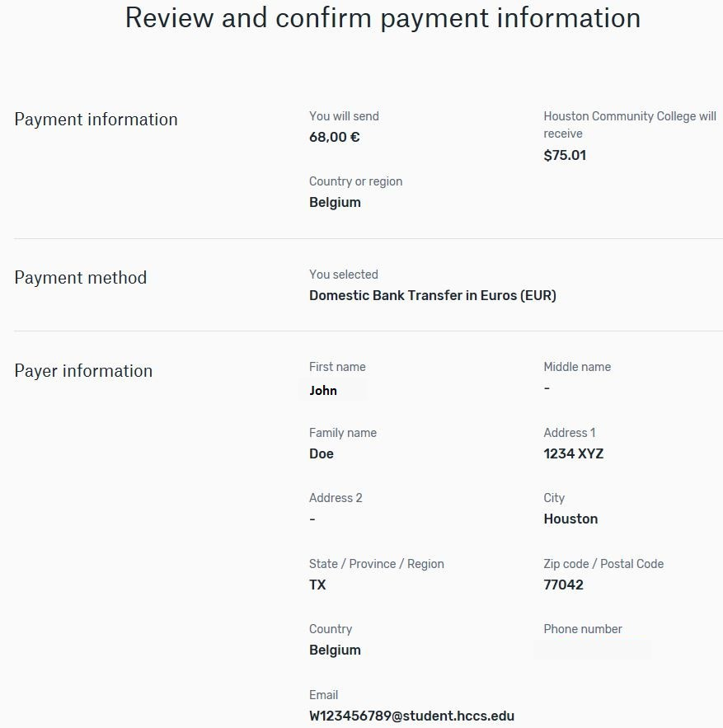Flywire – Review & Confirm Payment

The following screen will display the payer’s information, as well as the student account whose tuition and fees will be paid for. Please review carefully before proceeding to the next step.

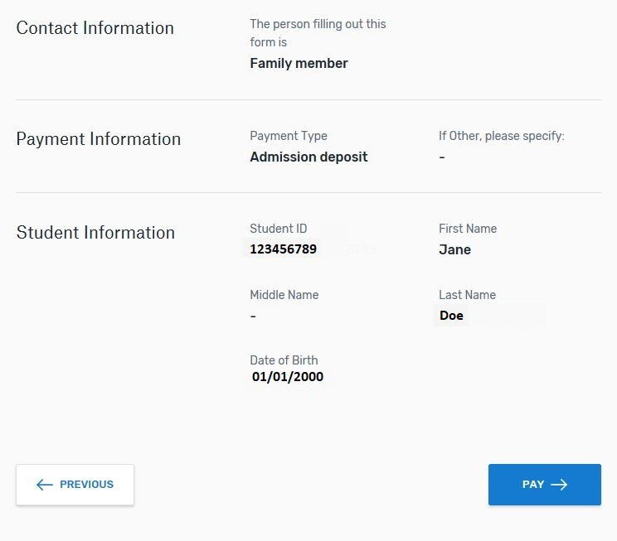Flywire – Review & Confirm Payment (continued)

If any information appears incorrect, you may click on the “Previous’ button to go back and make any necessary corrections.
If no changes are required, select the ‘Pay’ button to proceed to the next step.

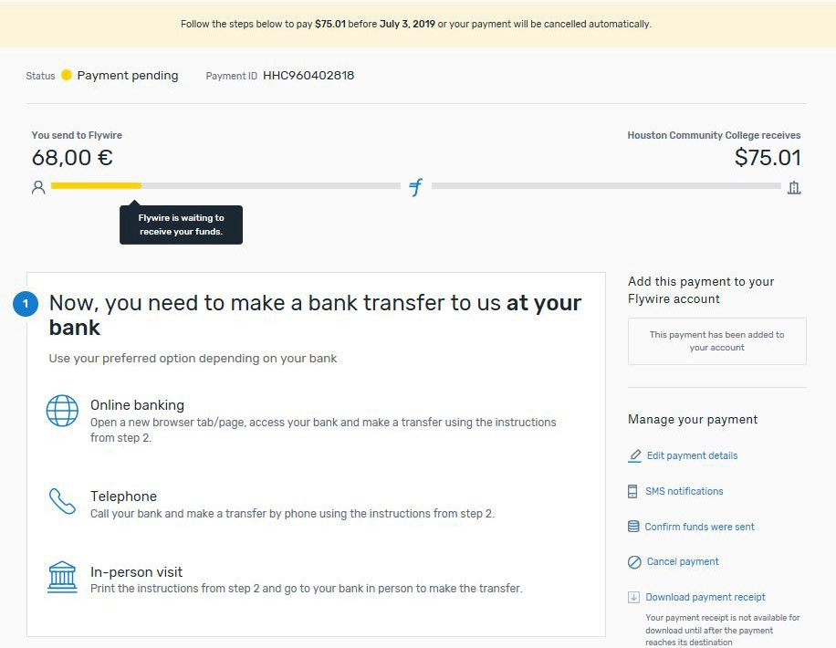Flywire – Initiating the Wire Transfer
*NOTE: Your payment is now pending with Flywire. You will need to initiate the bank transfer via online banking, telephone OR an in-person visit to the bank. To begin the process, proceed to the “Step 2 Make the bank transfer to Flywire’ to obtain Flywire’s payment instructions for wire transfers.

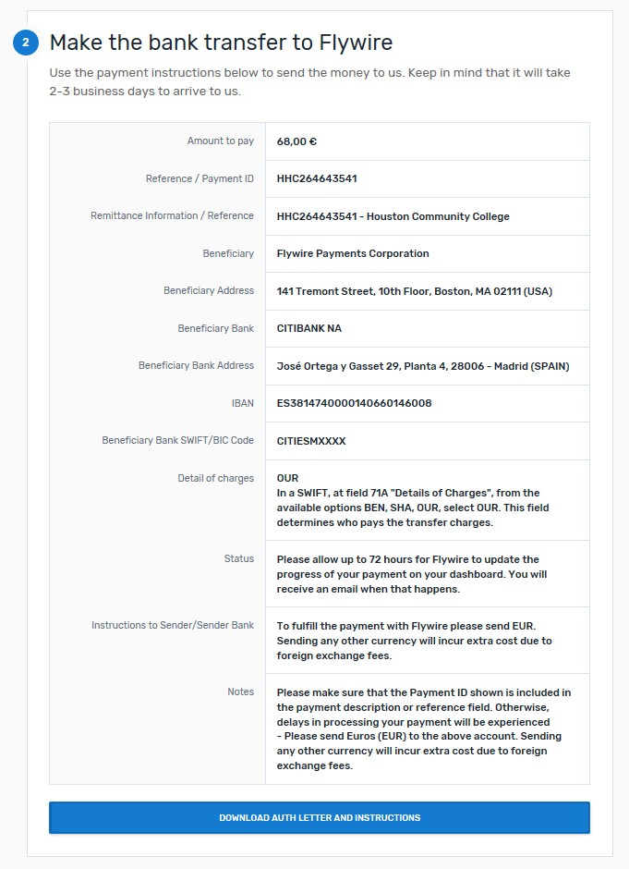Flywire – Initiating the Wire Transfer (continued)

Select the ‘Download Auth Letter and Instructions’ button to obtain transfer instructions.

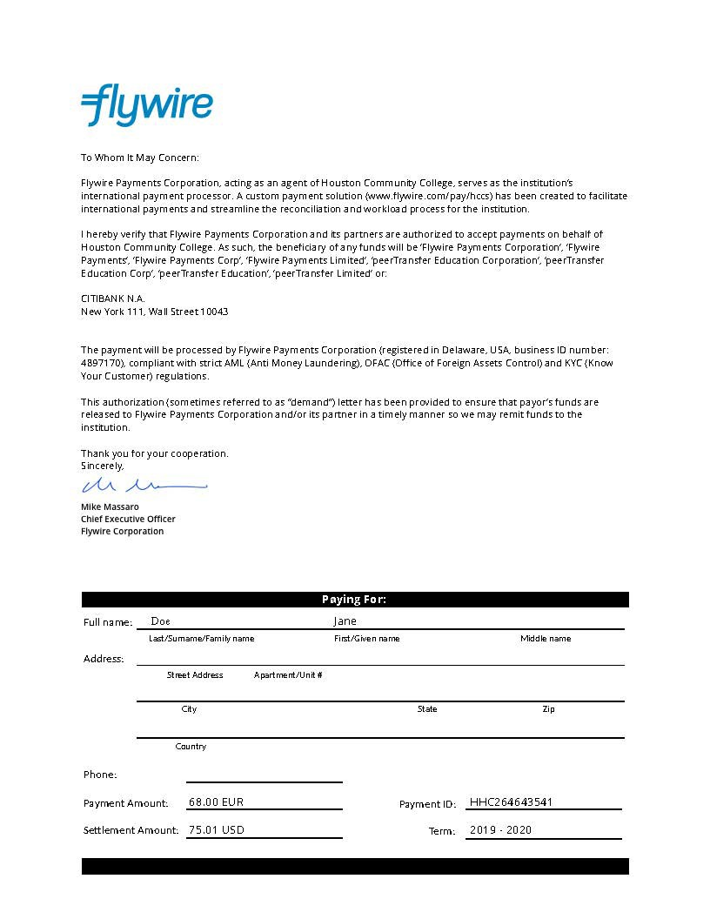
*NOTE: The next two pages represent an example of the document you will print and take in to your local bank

Payment Instructions
Summary
You've booked a payment of 68.00 EUR to Houston Community College on July 02, 2019. With an exchange rate of 1.10751, your institution will receive 75.01 USD.

Houston Community College has partnered with Flywire Payments Corporation or one of its affiliates to process international payments. As an agent of Houston Community College, Flywire remits funds to their accounts located in United States.
Additionally, this service allows Houston Community College to maintain the privacy of banking
information to reduce susceptibility to fraudulent activity.

Details for Money Transfer

Amount and Currency to send 68.00 EUR

Remittance Information/ Reference HHC264643541 - Houston Community College

Beneficiary Flywire Payments Corporation

Beneficiary Address 141 Tremont Street, 10th Floor, Boston, MA 02111 (USA)
Beneficiary Bank CITIBANK NA

Beneficiary Bank Address Jose Ortega y Gasset 29, Planta 4,
28006 - Madrid (SPAIN)
IBAN ES3814740000140550145008
Beneficiary Bank SWIFT/BIC Code CITIESMXXXX Detail of charges OUR
In a SWIFT, at field 71A "Details of Charges", from the available options BEN, SHA, OUR, select OUR. This field determines who pays the transfer charges.
Status Please allow up to 72 hours for Flywire to update the progress of your payment on your dashboard. You will receive an email when that happens.
Instructions to Sender/Sender Bank To fulfill the payment with Flywire please send EUR.
Sending any other currency will incur extra cost due to foreign exchange fees.
Notes Please make sure that the Payment ID shown is included in the payment description or reference field. Otherwise, delays in processing your payment will be experienced

- Please send Euros (EUR) to the above account. Sending any other currency will incur extra cost due to foreign exchange fees.

Important: Payment instru ctions can on ly be used once an d expire after July 04, 2019

Flywire – Finalizing the Wire Transfer
Once the funds have been submitted by your bank, simply select the ‘I’ve Sent The Funds’ button to notify Flywire of your payment.

